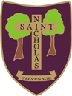
STEVENAGE ST. NICHOLAS CHURCH OF ENGLAND PRIMARY SCHOOL AND NURSERY

PARENTAL AGREEMENT FOR SCHOOL TO ADMINISTER MEDICINE DURING SCHOOL TIME

The staff at St Nicholas School will not administer medication to your child unless a parent/ guardian completes and signs this agreement.
Medicines should only be brought to school when essential; that is where it would be detrimental to a child’s health if the medicine were not administered during the school day. We will only accept medicines that have been prescribed by a doctor, dentist, nurse prescriber or pharmacist prescriber.
Medicines should always be provided in the original container as dispensed by a pharmacist and include the prescriber’s instructions for administration and dosage.

We will not accept medicines that have been taken out of the container as originally dispensed nor make changes to dosages on parental instructions.
IT IS PARENTS RESPONSIBILITY TO ENSURE MEDICATION IS IN DATE (INCLUDING INHALERS)
Name of School | St Nicholas School
Name of Child:
Class:
Medical condition/illness:

Medicine
Name/Type of Medicine
(as described on the container):
Date dispensed:
Expiry date:
Dosage and method:
Timing:
Special Precautions:
Are there any side effects that the school/setting needs to know about?
Self Administration: | Yes/No (delete as appropriate)
Procedures to take in an Emergency:

I understand that I must deliver the medicine personally to ………………………………… and accept that this is a service that the school is not obliged to undertake.
Parent signature
Date

Staff signature

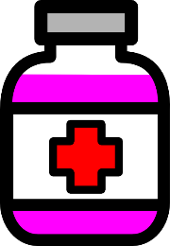
Name:
Record of Medication Administered in School

Date | Time | Medication & Dose | Signature/ Initials 1 | Signature/ Initials 2 | Any reactions

