
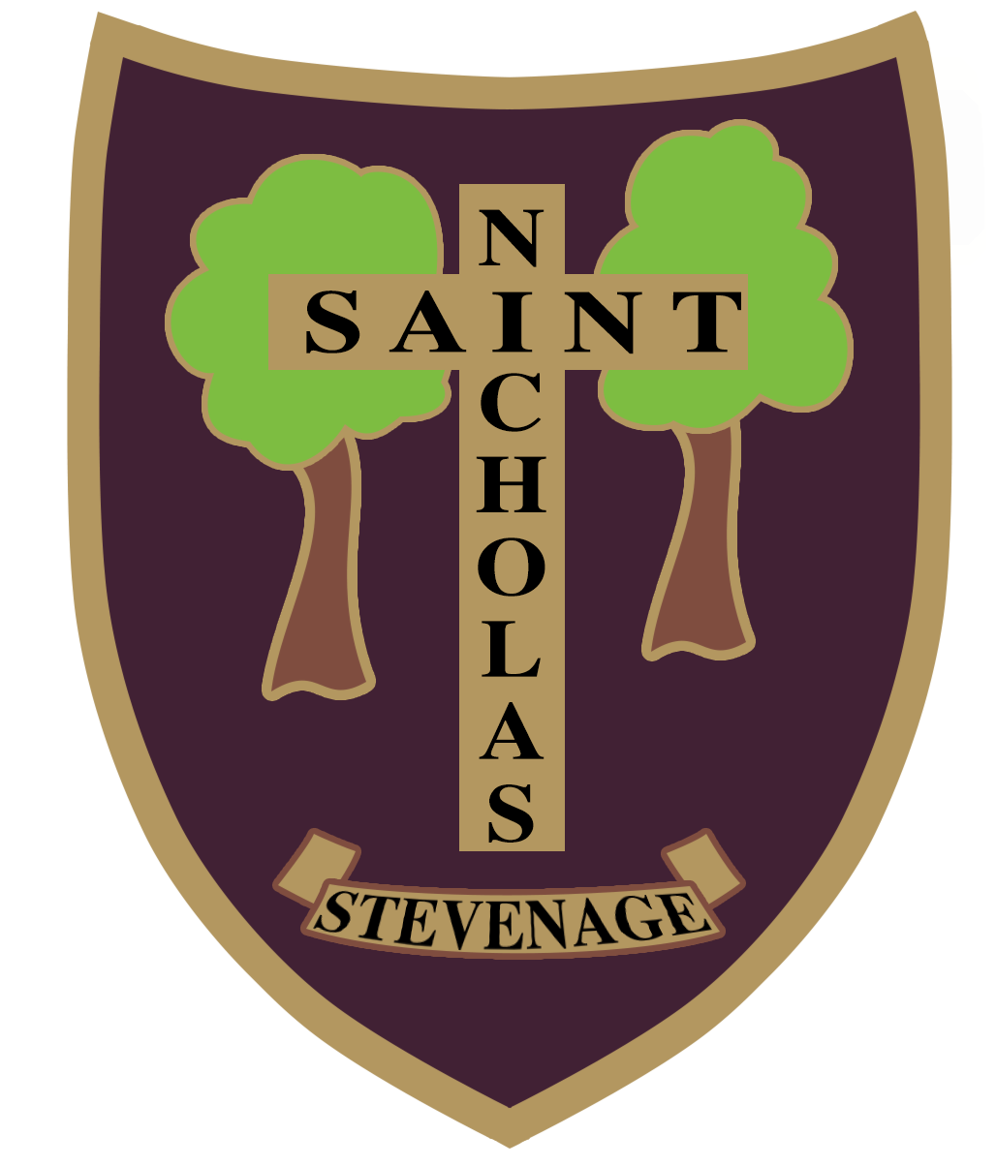 St Nicholas C of E (VA) Primary School and Nursery
Six Hills Way, Stevenage, SG2 0PZ

Tel: 01438 352706, Email: admin@stnicholas120.herts.sch.uk Website: www.stnicholas120.herts.sch.uk
Headteacher: Mrs Lorraine Collins BA (hons), MA

Dear Parent/ Carer,

Re Nursery Applications for September 2027
For children with dates of birth between 1.9.2023 – 31.8 2024

Thank you for your interest in our school, I have pleasure in attaching our application form and admissions policy which applies to 2027/28 entry to our Nursery.

We are now open to receive nursery applications for September 2027 entry and will allocate places on a first come, first served basis until we are full.

Visits to see the school will start in October so please ring nearer the time to make an appointment to visit.

We will only require the Supplementary Information Form (SIF) to be completed if we have filled our places. Only children on the continuing interest list (waiting list) will need to complete a SIF so that we can prioritise them. This form only applies if applying for a place under categories 4,5 or 6.

We look forward to receiving your completed application and copy of your child’s birth certificate in due course.

Yours sincerely

L Collins

Mrs L Collins
Headteacher

Learning, Loving, Living in God’s Family
“But I am like an olive tree flourishing in the house of God; I trust in God’s unfailing love forever and ever.” Psalm 52:8

Stevenage: St Nicholas Church of England Primary School and Nursery

ADMISSIONS POLICY YEAR OF ENTRY 2027
NURSERY YEAR

Thank you for considering St Nicholas, Church of England, Primary School and Nursery for your child. This policy outlines the admissions criteria and information that you will need when making an application for a place at our school.

St Nicholas is a Voluntary Aided Church of England School within the Diocese of St Albans. We are a school teaching Christian Values and educating the ‘whole child’ through our spiritual, moral, social and cultural teaching. We work closely with the Diocese, local Deanery and the Anglican Churches of Stevenage.
Voluntary Aided schools are mainly religious or 'faith' schools, although anyone can apply for a place. The Governing Body employs the staff and sets the admissions criteria. School buildings and land are normally owned by a charitable foundation, often a religious organisation. The Governing Body contributes to building and maintenance costs.

Our Vision ‘Learning, Loving, Living in God’s Family.’

How to apply
All applications must be made on the school paper application form available from the school office or downloaded from the website - https://www.stnicholas120.herts.sch.uk/Admissions

Parents should indicate on the form whether they require 15 hours or 30 hours provision. This can be confirmed before your child starts with us so is just an indication at this stage.

Parents should provide a copy of the short birth certificate with the application.

Which address to use?
Give your child's permanent address at the time you apply.
If you move after applying, send us proof of your new address.
Proof can be:
- a solicitor's letter upon completion (exchange of contracts not accepted) confirming your completion date
- a signed rental agreement (for at least 12 months) showing the start of your tenancy
- evidence that you have relinquished ties with the address you originally declared on your application form.

Fraudulent addresses or false information
We may ask for proof of your address at any time or do spot checks on the information parents have provided on the application form, particularly if we are over-subscribed. We may withdraw the nursery place offer if we find a fraudulent address or information has been provided.

Admissions information for nursery only

Our planned intake number which is the maximum number of children we will admit in the nursery is 30. We reserve the right to reduce this number if the needs of the children in the class require a higher staff ratio making it practically not possible to admit 30 children.
If we have fewer than 30 applications, then all will be offered places for morning nursery.

We will allocate up to 24 full time places. We will treat all applications with the same priority whether applying for part time or full time places.

Parents of children admitted to our Nursery must re-apply for a place in the Reception class for the following year.

Attendance at our Nursery does not guarantee a place in Reception.

The school does not have any specific units or facilities for pupils with particular special needs or for pupils with physical disabilities. The school is, however, on a level site, and all the accommodation is on one floor. As far as possible, the school will ensure that pupils with disabilities have access to the same opportunities as other pupils.

All nursery aged children are entitled to 15 hours free nursery provision. St Nicholas School offers this on a Monday to Friday basis only from 8.45am – 11.45am. Please note all children are expected to be in school for 8.45am as we need to secure the school gates at 8.55am.

Parents may be eligible for 30 hours of free nursery provision and will need to apply for an eligibility code. Please see the following website to check conditions of eligibility and to apply.
https://www.gov.uk/apply-free-childcare-if-youre-working

If eligible for 30 hours, St Nicholas School offers 30 hours on a Monday to Friday basis only from 8.45am – 2.45pm. An additional 30 minutes may be provided at a charge from 2.45pm – 3.15pm so that nursery children finish the same time as the rest of the school.
The lunch time period is included in the 30 hours but lunch is not provided so children will need to bring in a packed lunch from home. However, if you feel you may be eligible for Free School Meals, you can apply here - Free school meals and other benefits | Hertfordshire County Council

30 Hours Provision
Places for 30 hours will only be confirmed on receipt of the eligibility code. The code will be requested in July. Parents have to reapply each term for their 30 hours’ provision. A child will not be able to start the additional hours without the code.
If parents are not eligible for 30 hours funded provision, they may be able to pay for extra hours subject to spaces being available.

Time Scale
We will be open to receive nursery applications from September 2026 and will allocate places on a first come, first served basis until we are full.

Oversubscription
Continuing interest list (waiting list).

In the event of more applications than available places, the school will maintain a continuing interest list (waiting list). If a place becomes available in the school, it will be offered to the child that best meets the published admission rules (see below).

How places are offered to those on a continuing interest list

The Governing Body, as the Admission Authority, will rank the applications in line with this policy.

Parents/Carers of children who have an EHC (Education, Health and Care) Plan should contact the school to discuss how the school can meet your child’s needs.

If there are more applications than there are places available, the Governors will admit pupils according to the criteria below in order of priority. Please note that special priority will not be given to those families wanting 30 hours.

Category 1

Children Looked After and children who were previously looked after, including those who appear (to the admissions authority) to have been in state care outside England, and ceased to be in state care as a result of being adopted. Previously looked after children are those who were looked after but ceased to be so because of being adopted or becoming subject to a Child Arrangements Order, or a Special Guardianship Order.
Places are allocated to children in public care according to Chapter 2, Section 7 of the School Admissions (Admission Arrangements and Co-ordination of Admission Arrangements) (England) Regulations 2012.

A “child looked after” is a child who is:
- in the care of a local authority, or
- being provided with accommodation by a local authority in the exercise of their social services functions (section 22(1) of The Children Act 1989)
All children adopted from care who are of compulsory school age are eligible for admission under rule 1.
Children in the process of being placed for adoption are classified by law as children looked after providing there is a Placement Order and the application would be prioritised under Rule 1.
Children who were not “looked after” immediately before being adopted, or made the subject of a child arrangement order or special guardianship order, will not be prioritised under rule 1. Applications made for these children, with suitable supporting professional evidence, can be considered under category 3.
¹ Child arrangements order
Under the provisions of the Children and Families Act 2014, which amended section 8 of the Children Act 1989, residence orders have now been replaced by child arrangements orders which settle the arrangements to be made as to the person with whom the child is to live.
² Special guardianship order
Under 14A of The Children Act 1989, an order appointing one or more individuals to be a child’s special guardian or guardians.
Children previously looked after abroad and subsequently adopted will be prioritised under Rule 1 if the child’s previously looked after status and adoption is confirmed by Hertfordshire’s “Virtual School”.
The child’s previously looked status will be decided in accordance with the definition outlined in The Children & Social Work Act 2017:
i. to have been in state care in a place …….. because he or she would not otherwise have been cared for adequately, and
ii. to have ceased to be in that state care as a result of being adopted.
A child is in “state care” if he or she is in the care of, or accommodated by –
(a) a public authority,
(b) a religious organisation, or
(c) any other organisation the sole or main purpose of which is to benefit society.

Category 2

Siblings of children already enrolled at the school. Please note this does not include current Y6 children who will be leaving the school or children currently enrolled in the nursery.
Sibling refers to a brother or sister, half brother or sister, adopted brother or sister or the child of the parent/carer’s partner or a child looked after or previously looked after and in every case, the child should be living permanently in a placement within the home as part of the family household from Monday to Friday at the time of application. The sibling must be in the school at the time of this application and be likely to remain in the school at the proposed date of admission. A sibling must be on the roll of the named school at the time the younger child starts.
If a place is obtained for an older child using fraudulent information, there will be no sibling connection available to subsequent children from that family.
A sibling link will not be recognised for children living temporarily in the same house, for example a child who usually lives with one parent but has temporarily moved or a looked after child in a respite placement or very short term or bridging foster placement. If an applicant lives at more than one address, the sibling must also reside at the same address for the majority of the school week., The sibling’s address will be verified by the school.

Category 3

On very exceptional social or medical grounds.
On very exceptional social or medical grounds refers to known social or medical needs where there are exceptional reasons which make it essential that a child should attend St Nicholas and where it is the only school locally that could meet the child’s needs. Parents will need to submit specific professional evidence (e.g. from a consultant doctor or senior social worker) that justifies why only St Nicholas can meet the child’s needs or which explains the exceptional family circumstance which clearly show that only St Nicholas can meet the child’s needs. The Governors will consider each application on its own individual merits.

Category 4

Children of practising Anglicans, one or more of whose parents/carers have, at the time of application, shown commitment to the Church of England by worshipping at least twice a month for the two years immediately prior to an application being made. Applicants in this category are required to provide evidence in the relevant section of the SIF duly completed by their Parish Priest. Applicants in this category should note there is an expectation that the family will continue to attend church after admission to the school.
Attendance at the place of worship – it is recognised that some families are unable to attend the ‘main act of worship’ on a regular basis but show commitment through attendance at weekday events instead. This can be verified by the Priest, Minister, Pastor or appropriate religious leader using the Supplementary Information Form. This attendance should still meet the minimum requirement of twice monthly for two years prior to application.

Category 5

Children from practising families of other Christian denominations, one or more of whose parents/carers have, at the time of application, shown commitment to that Place of Worship by attending at least twice a month for the two years immediately prior to an application being made. Applicants in this category are required to provide the relevant section of the SIF duly completed by their Priest, Minister or Pastor. Applicants in this category should note there is an expectation that the family will continue to attend church after admission to the school.
‘Other Christian Denominations’ (category 5) are established members of Churches together in England or the Evangelical Alliance or who profess Trinitarian Faith.

Category 6

Children from families of other established World Faiths whose parents/carers have, at the time of application, shown commitment to that place of worship by attending at least twice a month for the two years immediately prior to an application being made. Applicants in this category are required to provide the relevant section of the SIF duly completed by their religious leader. Applicants in this category should note there is an expectation that the family will continue to attend their place of worship after admission to the school.
Established World Faiths (category 6) include the following: Judaism, Hinduism, Sikhism, Buddhism and Islam.

Category 7

Any other children.

FURTHER INFORMATION FOR CATEGORIES 4, 5 AND 6
Attendance at the place of worship – it is recognised that some families are unable to attend the ‘main act of worship’ on a regular basis but show commitment through attendance at weekday events instead. This can be verified by the Priest, Minister, Pastor or appropriate religious leader using the Supplementary Information Form. This attendance should still meet the minimum requirement of twice monthly for two years prior to application.

Applicants who are seeking admission under category 4, 5 or 6 will be required to complete and submit a Supplementary Information Form (SIF) as evidence of their eligibility.
In the event that during the period specified for attendance at worship the church or, in relation to those of other faiths, relevant place of worship has been closed for public worship and has not provided alternative premises for that worship, the requirements of these admissions arrangements in relation to attendance will only apply to the period when the church or, in relation to those of other faiths, relevant place of worship or alternative premises have been available for public worship.

OVERSUBSCRIPTION
Where there is oversubscription in any of the above criteria, the places will be allocated on the basis of distance from the child’s permanent home address to the school using Hertfordshire County Council’s measuring system which is a ‘straight line’ distance measurement from the address point of the child’s home to the address point of the school. A ‘straight line’ distance measurement is used in all home to school distance measurements for community and VC schools in Hertfordshire. Distances are measured using a computerised mapping system to two decimal places. The measurement is taken from the AddressBase Premium address point of your child’s house to the address point of the school. AddressBase Premium data is a nationally recognised method of identifying the location of schools and individual residences.
In the case of twins and multiple birth children, if one twin/multiple birth child is offered the final place available, the other/s can also be offered places over the planned admission number (PAN) as exceptions to the infant class size legislation.
The Governors cooperate with the Fair Access policies of the Local Authority and children admitted under the protocol will be prioritised above those on the Continuing Interest list (waiting list) and above the PAN if necessary.
HOME ADDRESS
The address provided on the application form must be the child’s current permanent address at the time of application
· “At the time of application” means the closing date for applications
· “Permanent” means that the child has lived at that address for at least a year
Where a family has not lived at an address for a year at the time of application, they must be able to demonstrate that they own the property or have a tenancy agreement for a minimum of 12 months and the child must be resident in the property at the time of application. If, because of the nature of the agreement, it is not possible to provide a 12-month tenancy agreement, alternative proof of address will be requested.
It is for the Governing Body (as the admission authority) to determine the address to be used for admission purposes.
The application can only be processed using one address. If a child lives at more than one address (for example due to a separation) the address used will be the one where the child lives for the majority of the school week. If a child lives at two address equally, parents/carers should make a single joint application naming one address.
If the child’s living arrangements change after you apply and they now spend the majority of the school week living at a different address, you must provide evidence of the new permanent address.
Addresses will be verified as necessary with Hertfordshire County Council’s Shared Anti-Fraud Service.
Applications made as part of the main Reception admissions round and in-year admission applications are processed by Hertfordshire County Council (“HCC”) on behalf of the Governing Body, in accordance with HCC’s published coordinated admission schemes.
If a child’s permanent residence is disputed, parents/carers should provide court documentation to evidence the address that should be used for admission allocation purposes. If two applications are received, with different addresses, neither will be processed until the address issue is reconciled.
If HCC receives two different applications for the same child from the same address e.g. containing different preferences, parents/carers will be invited to submit a joint application or provide court documentation to evidence the preferences that should be used for the admission process. Until the preference issue is reconciled, neither application will be processed.
For the main Reception admission round, if the initial differing applications (one or both) were received by HCC “on-time”, an amended joint application will also be considered “on-time” if received before 2nd February 2027 (the late deadline). If the amended joint application is received after 2nd February, it will be treated as “late”.

TIE BREAK

When there is a need for a tie break where two different addresses are the same distance from a school, in the case of a block of flats for example, the lower door number will be deemed nearest as logically this will be on the ground floor and therefore closer. If there are two identical addresses of separate applicants, the tie break will be random. Every child entered onto the HCC admissions database has an individual random number assigned, between 1 and 1 million, against each preference school. When there is a need for a final tie break the random number is used to allocate the place, with the lowest number given priority.

Unsuccessful applications

Appeals.

There is no right of appeal for Nursery children.
Children who are unsuccessful can go on the school waiting list.

Help and advice

If you would like more guidance, help or advice relating to admissions, please contact the school office on 01438 352706.

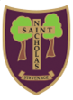
St Nicholas C of E (VA) Primary School and Nursery
Six Hills Way, Stevenage, SG2 0PZ

Tel: 01438 352706, Email: admin@stnicholas120.herts.sch.uk Website: www.stnicholas120.herts.sch.uk
Headteacher: Mrs Lorraine Collins BA (hons), MA

NURSERY APPLICATION FORM 2027/2028
Please complete the form in full
and attach a copy of your child’s short birth certificate.

PLEASE USE BLOCK CAPITALS
Child details
First name:
Middle name:
Family name:
Date of Birth: |  | / / |  | Gender: | M/F
NHS number: |  |  |  | __ __ __ / __ __ __ / __ __ __ __
Your relationship to the child: (e.g. mother/father/carer/ stepmother/father/ social worker)
Your child’s permanent address (at time of application)

Address:

Special Educational Needs  Does your child have a Statement of Special Educational Needs or Educational Health and Care Plan (EHCP)? |  |  |  |  | Yes/No
At risk  Is your child, or a sibling of your child, subject of an inter-agency child protection plan and has been placed on the Child Protection Register? (Please provide evidence with this form) |  |  |  |  | Yes/No
Children in Public Care Is your child looked after, or was previously looked after and is now adopted, or with a child arrangements or special guardianship order? |  |  |  |  | Yes/No
Social or medical reasons  Do you have a particular medical or social need to go to this school? (Please provide supporting evidence with this form) |  |  |  |  | Yes/No
If you have a sibling at this school, enter their name and date of birth:

Name and contact details of the Early years setting your child attends
or has attended (if applicable)

In the event of over subscription, under which category of the Admissions Policy are you making this application? (Please tick appropriate box)
Please refer to our Admissions Policy. A SIF may be required for categories 4,5 and 6.
1: - Looked After Child
2: - Sibling Rule
3: - Exceptional Social or Medical
4: - Children of Practising Anglicans
5: - Children of Practising Other Christian Denominations
6: - Children of Established World Faiths
7: - Any Other Children

Please indicate if you want your child to attend mornings only or all day:
 | Monday to Friday |  |  |  |  |  |  | Total hours
AM only |  |  |  |  |  |  |  | 15
All Day |  |  |  |  |  |  |  | 30
If applying for 30 hours free childcare, you will need to provide your HMRC code by beginning of July 2027:
If you have any other requirements, please enter here:
Please complete the details for both parents who have parental responsibility:
Parent/carer 1 details |  |  |  |  |  | Parent/carer 2 details
Title:
Forename:
Surname:
Address:
Email address:
Telephone numbers - Daytime
Telephone numbers
- Mobile
I confirm that the details above are correct to the best of my knowledge.
Signature of parent/carer:
OFFICE USE ONLY: |  |  | Date Received:
 |  |  | Distance:

DECLARATION
The information I have given on this form is complete and accurate. I understand that my personal information will be held securely and will be used only for local authority purposes.
I agree to St Nicholas School using this information to consider my application for a nursery place. I understand that if any part of this completed application form is found false the offer of a place will be withdrawn.
I understand that the completion of an application form does not guarantee a place in the nursery class.
I understand that, if offered a place in the nursery class, I will have to apply separately for a place in reception.

Signature of parent/guardian: ………………………… Date: ………..…………

Thank you for completing this information. Please return to the school office as soon as possible.
Notes to parent

How the information on this form will be used:

By completing this form and signing the declaration you are agreeing for St Nicholas School, if they are oversubscribed, to check whether your child’s details meet the school’s published admission rules and if he/she can be offered a nursery place.

Any personal data collected will be treated as confidential under the principles of the Data Protection Act 2018. We will not use the data for any other purpose, nor will we share your data with any third parties other than the Department for Education (for statutory reporting), Hertfordshire County Council departments who may from time to time send you advice, guidance and information relating to changes to early years provision and educational services that are relevant and/or of benefit to your child, and your local children’s centre who support the local authority by assisting families to access the services that children are entitled to. We may use the church or religious places of worship information taken from the SIFs in order to facilitate communication between these establishments and our school.
We may retain the SIFs until the end of the academic year of admission.

Children who have been adopted from care or are subject to a special guardianship order or a child arrangements order.

Eligibility will be based on your declaration that your child was formally a looked after child and on the evidence of their status e.g. a copy of the relevant order. This form and a copy of the relevant order should be seen by the school and they will confirm with Hertfordshire County Council that they have seen confirmation and enable a place to be offered under this criteria.

